**M.F. Mohammed Faayiz**

7/41 Thavakkayan Street, Pallapatti, Karur - 639205

7305852980 [mffaayiz235@gmail.com](mailto:mffaayiz235@gmail.com)

[LinkedIn](https://www.linkedin.com/in/m-f-faayiz-5a914725a) [GitHub](https://github.com/mffaayiz235)

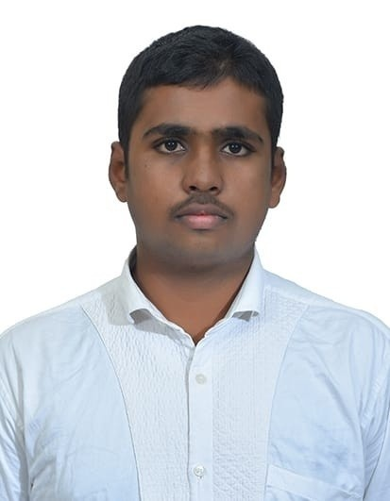

# Objective

To develop **innovative, scalable software solutions** that enhance user experience and drive product growth in a **dynamic, product-based company**. Passionate about **software development, IoT, and creative design**, with a strong foundation in **data structures and web technologies**.

# Experience

# Data Analyst Intern*(June 2023 – Sept 2023)*

# Cleaned and analyzed customer behavior data using Python (Pandas, NumPy)Created interactive dashboards using Tableau to visualize trends.Helped reduce churn rate by 10% through predictive modeling.

# Skills

* **Programming Languages:** Python, C, Java
* **Web Technologies:** HTML, CSS,JS, MySQL
* **Frameworks and Tools:** GitHub, VS Code, Canva
* **Database Management:** MySQL, MongoDB
* **Cloud Platforms:** Microsoft Azure

# Soft Skills

* **Critical Thinking:** Problem analysis and solution implementation.
* **Time Management:** Efficient task and deadline handling.
* **Leadership:** Team management and event organization.
* **Communication:** Clear written and verbal skills.
* **Adaptability:** Quick learning of new technologies.

# Certifications

* Programming in Java – NPTEL (2023)
* Introduction to Industry 4.0 and Industrial Internet of Things – NPTEL (2024)
* Front End Development-CSS - Great Learning (2024)
* Web Development – RINEX (2024)
* JavaScript Essential 1 – Cisco Networking Academy (2025)
* Sql and Relational Database - Cognitive Class.ai (2024)

# Education

**B.Tech – Information Technology CGPA:** 7.5(2022 – 2026)

*M. Kumarasamy College of Engineering, Karur, Tamil Nadu*

**Higher Secondary Certificate (HSC) Percentage:** 74%(2021 – 2022)

*Crescent Matriculation Higher Secondary School, Karur*

**Secondary School Leaving Certificate (SSLC) Percentage:** 84%(2019 – 2020)

*Crescent Matriculation Higher Secondary School, Karur*

# Projects

**E-Ration Web Application** (2023 - 2024)

*Tech Stack: HTML, CSS, PHP, MySQL*

* Developed a **web-based ration management system** to assist uneducated users in checking ration shop availability.
* Streamlined communication for **real-time updates** on stock availability, employee status, and operational details.

**Web-Based No Due Form Generation** (2024)

*Tech Stack: HTML, CSS, JS, PHP, MySQL*

* Automated the **no due clearance process**, reducing manual work and human errors.
* Enabled users to **track dues, request clearance**, and generate a no-due form efficiently, ensuring trans- parency.

**Food Classification and Nutrition Analysis Using Artificial Intelligence** (2025)

*Tech Stack: Python*

* Implemented an **AI-powered image recognition system** to classify various food items accurately.
* Integrated **nutritional analysis** to provide real-time data on calories and macronutrients for health monitoring.

# Declaration

I hereby declare that all the information provided in this resume is true and correct to the best of my knowledge.

**Signature**

(M.F. MOHAMMED FAAYIZ)